**PBL 7 : String manipulation, Numeric manipulation and SELECT CASE statement.**

**String manipulation**

1. Write a program that will print the reverse of a word input by the user.

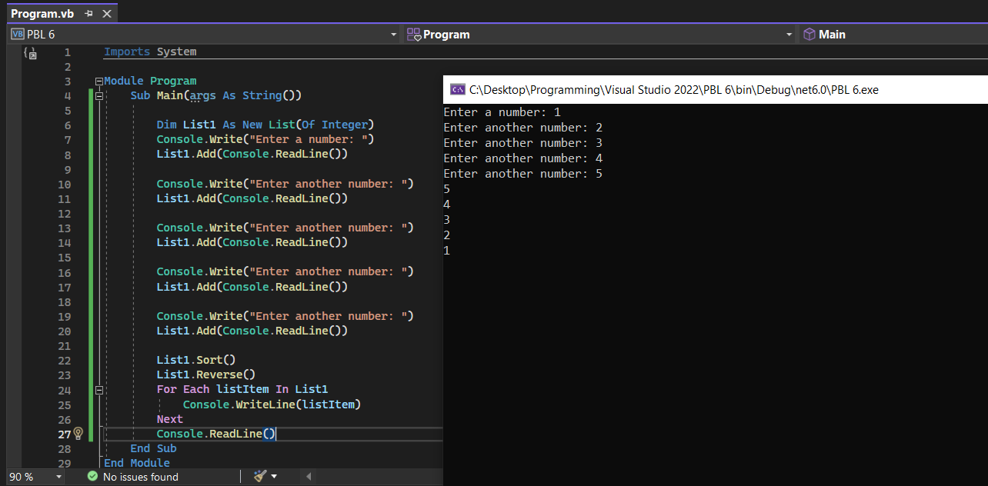

2. Write a program that will print the ASCII value of the last three letters in a word.

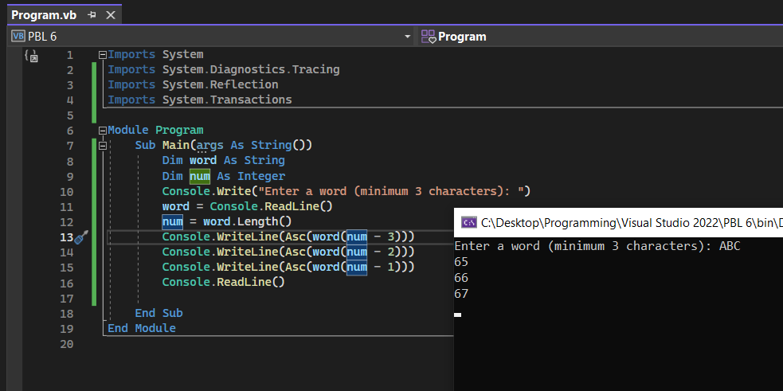

3. Imagine writing a message to a friend and the message is to be encrypted when it is sent over the internet. Write a program to encrypt and decrypt the message.

(Tips : Each character is replaced by the 5th character in the ASCII table.)

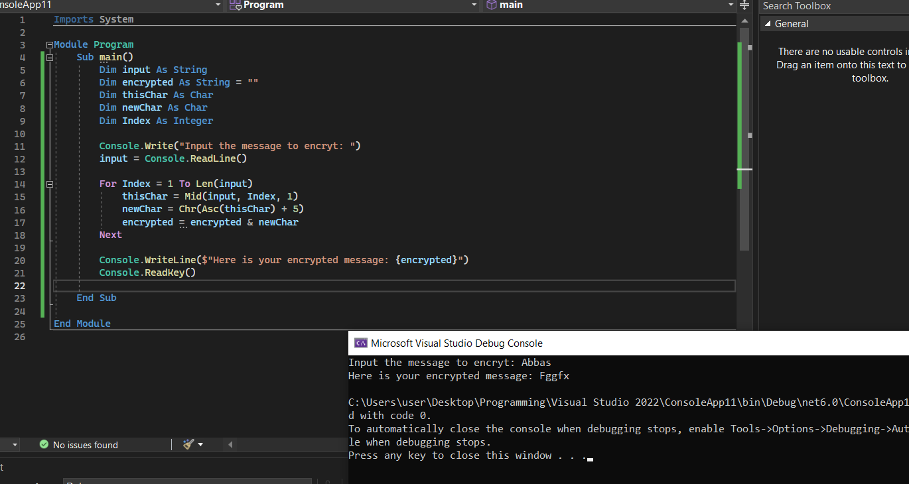

**Numeric manipulation**

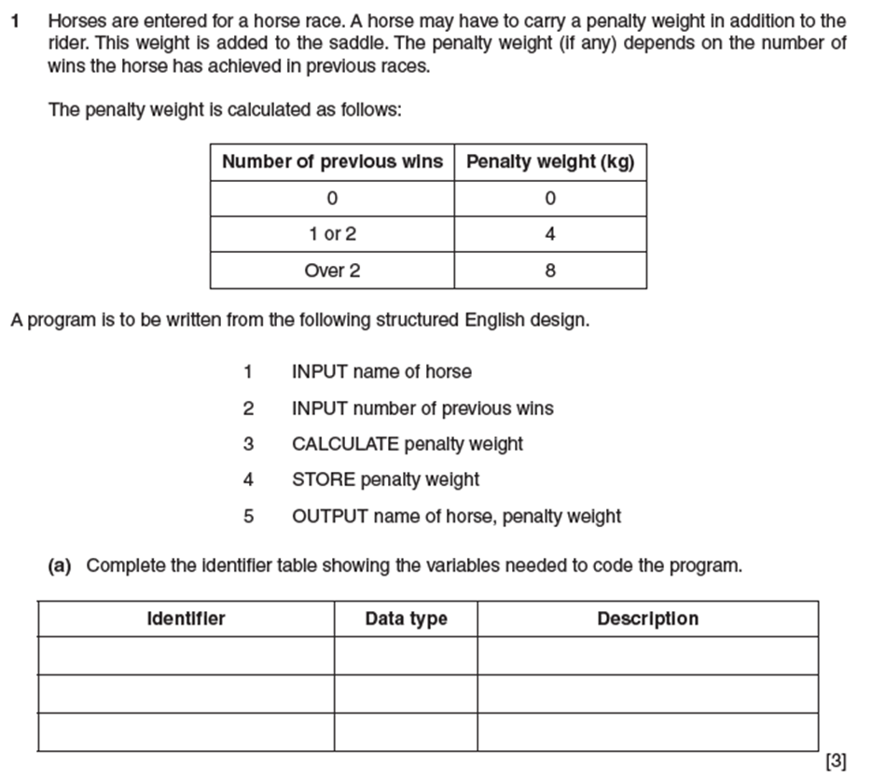

**Program 1:**

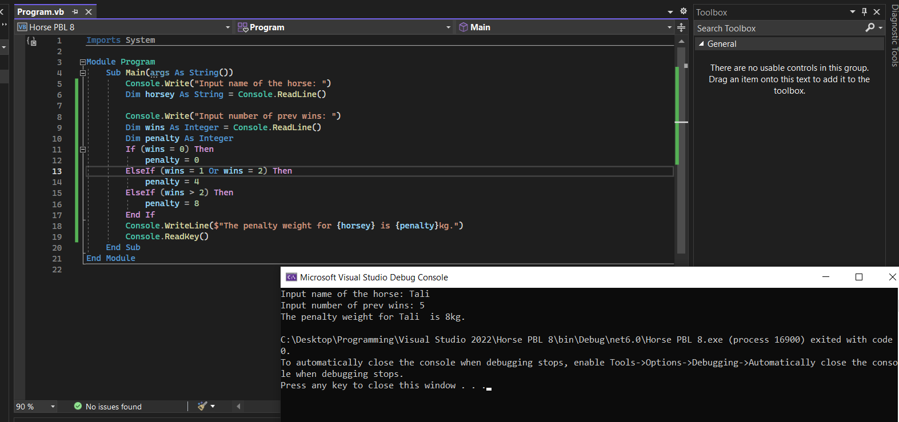

**SELECT CASE statement**

1. Write a program using CASE technique that grades student exam marks.

75 – 100 = A

65 – 75 = B

55 – 65 = C

45 – 55 = D

< 45 = F

Your program must check if marks input are between 0 to 100, any marks input outside these range must be indicated as invalid.

